GOLD COAST CHART
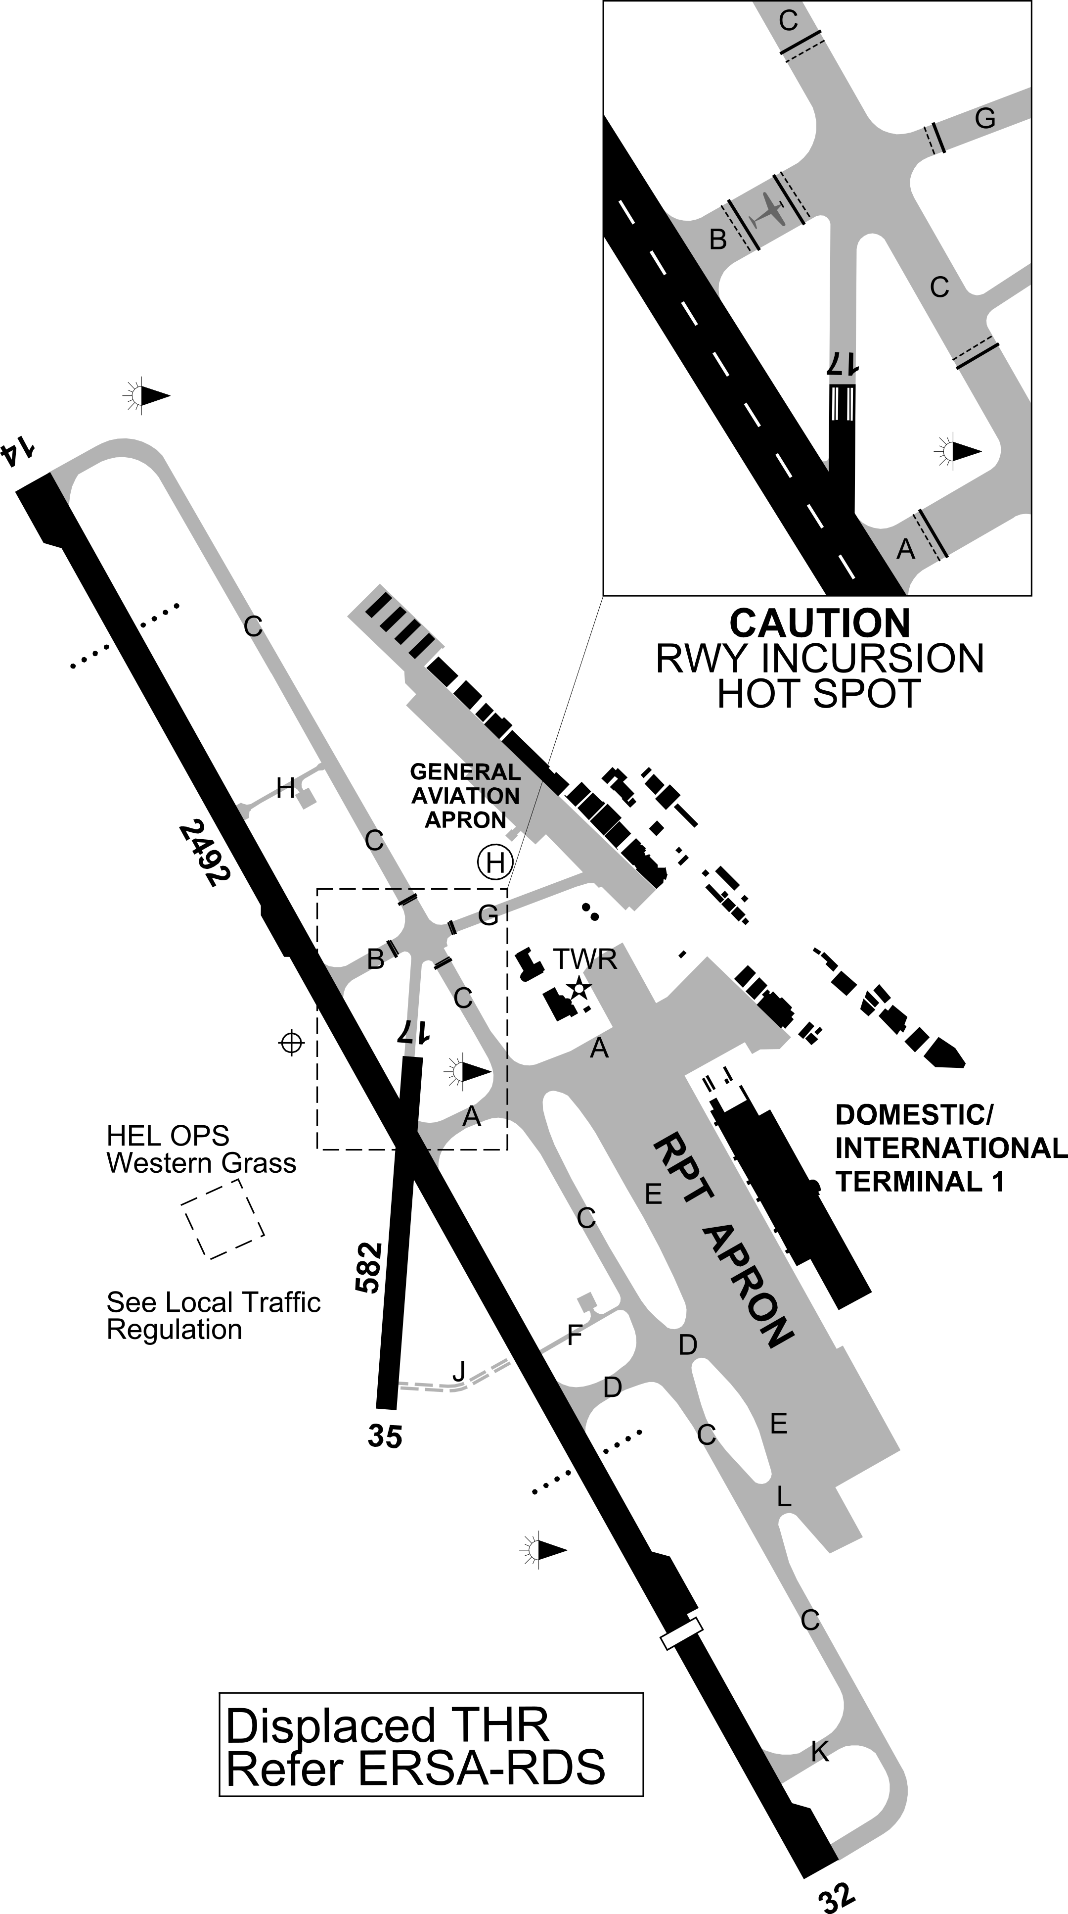

Original Source: AirServices AIP → ERSA 02DEC2021 → YBCG

