ARCHERFIELD CHART

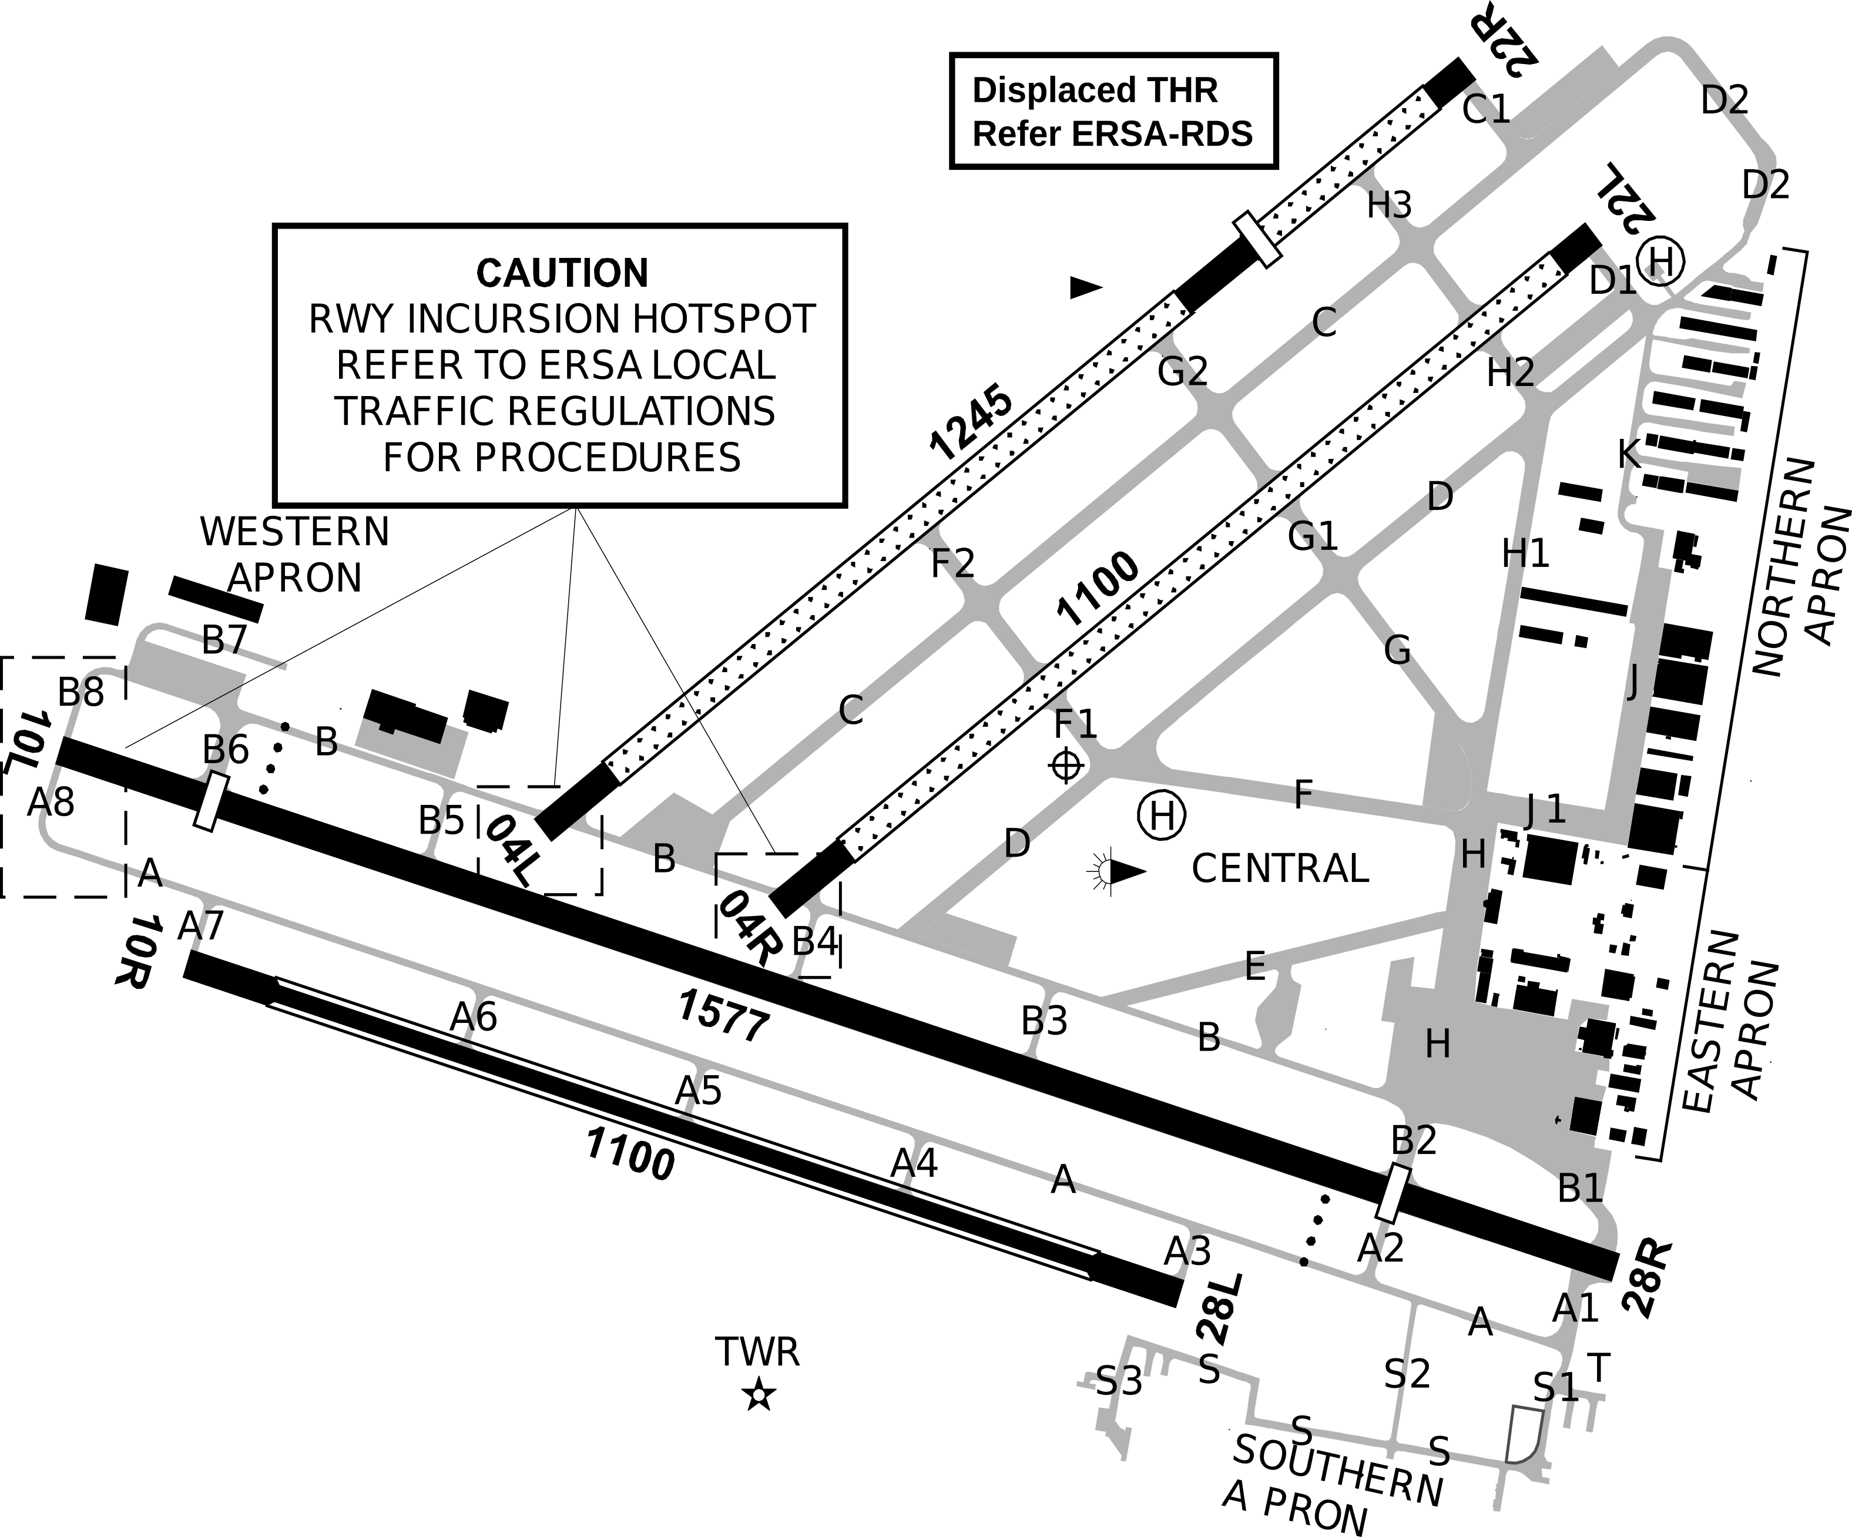

Original Source: AirServices AIP → ERSA 24MAR2022 → YBAF

